
SOUTH EAST EDUCATION DIVISION EXAMINATIONS

2026 MALAWI SCHOOL CERTIFICATE OF EDUCATION MOCK EXAMINATION

MATHEMATICS
Subject Number: M131/II
Thursday, 19 March Time Allowed: 2h 30min
8:00 - 10:30 am
PAPER II
(100 marks)

Instructions:

- This paper contains 14 printed pages. Please check.
Question Number | Tick if answered | Do not write in these columns
1
2
3
4
5
6
7
8
9
10
11
12
- Write your Examination number at the top of the question paper.
- Answer all the six questions in Section A and any four questions from section B.
- The maximum number of marks for each answer is indicated against each question.
- Electronic calculators may be used.
- In the table provided on this page, tick against the number of the question you have answered.
- At the end of examination, hand in your paper to the invigilator.

©2026 SEED MOCK Turn over

Section A (60 marks)
Answer all the six questions in this section in the spaces provided.
- a. Express 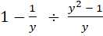 as a single fraction, in its lowest form. (5 marks)

b. Without using a calculator, simplify 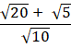 , leaving your answer with a rational denominator (5 marks)

Continued/…
- a. The sum of terms of an Arithmetic Progression (AP) is given by
Calculate the common difference of the progression. (4 marks)

b. Table 1 shows lengths of some specimens used in Agriculture practical.
Table 1
Length (cm) | 10 – 20 | 21 – 31 | 31 – 41 | 42 – 52 | 53 – 63
Frequency | 9 | 11 | 14 | 6 | 5

Calculate mode of the lengths
(5 marks)

Continued/…
- a. A basket contains 5 mangoes and 7 bananas. Two fruits are selected at random,
one after another and eaten. Use a probability tree diagram to find the probability that a mango and a banana are eaten.
(6 marks)

b. Make subject of the formula: 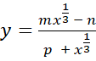 (4 marks)

Continued/…

- a. Figure 1 shows two unequal circles ABD and CBD interesting at B and D. EA and
EC are tangents to the circle at A and C respectively. AB and BC are diameters of
circles ABD and CBD respectively.

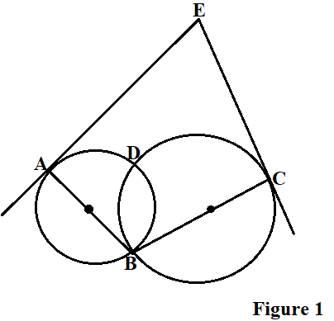
Prove that
(i) ABCE is a cyclic quadrilateral

(ii) angle ABD = angle CBE
(5 marks)

Continued/…
b. A ship leaves port A to port B travelling on a bearing 035⁰ for 50km. It then turns due east travelling at 25km/hr for 4 hours, and reaches port C. calculate the distance between ports A and C, to the nearest kilometre.
(6 marks)

- a. An object starts from rest and accelerates uniformly at 10m/s² in 4 seconds. It
further accelerates to a velocity of 100m/s in the next 3 seconds. It maintains this
velocity for 3 seconds until it comes to rest, in another 2 seconds.
- Using a scale of 2cm to represent 20m/s on the vertical axis and 2cm to
represent 2 seconds on the horizontal axis, draw the velocity – time graph for
the motion.
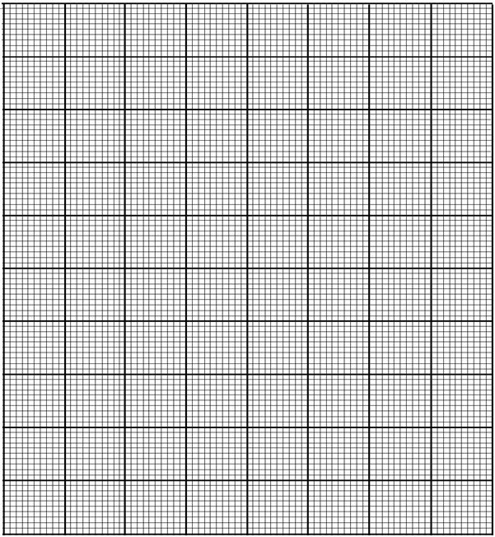
(5 marks)

(ii) Use your graph to calculate the total distance covered during deceleration
(2 marks)

Continued/…
(b) Figure 2 shows triangle OBC in which and . R is a point on
CB such that
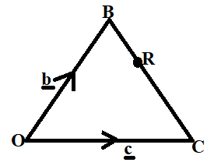
Figure 2

Express OR in terms of and
(4 marks)

- a. Prove the theorem which states that an angle between a chord and a tangent is equal
to the angle subtended by the chord in alternate segments.
(6 marks)

Continued/…
b. Triangle PQR has vertices P(2,-2), Q(6,2) and R(8,0). If triangle PQR is enlarged
with centre (0,0) by a scale factor of 3, find the coordinates for the vertices of the
image triangle .
(3 marks)

Section B (40 marks)
Answer any four questions from this section in the spaces provided.

- Solve the equation (10 marks)

Continued/…
- In a group, 40 people were asked whether they prefer Facebook, WhatsApp or TikTok as their social media platforms.

- 8 people chose all the three kinds of social media platforms
- 7 people chose Facebook and WhatsApp only
- 4 people chose Facebook and TikTok only
- 2 people chose WhatsApp and TikTok only
- 10 people chose TikTok only
- people chose Facebook only
- students chose WhatsApp only
(a) Present this information in a Venn diagram (6 marks)

(b) Use the Venn diagram to find the number of people who chose Facebook
(4 marks)

Continued/…
- Figure 2 shows a tank with rectangular faces
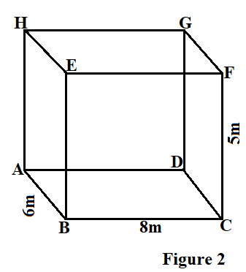
Calculate the angle between line BG and plane ABCD, to the nearest degree.
(10 marks)

Continued/…
- Table 2 shows some values of and for the equation .
Table 2
 | -3 | -2 | -1 | 0 | 1 | 2 | 3
 | -15 | 0 |  | 0 | -3 |  | 15

(i) Complete the table of values
(2 marks)
(ii) Using the scale of 2cm to represent 1 unit on the horizontal axis and 2 cm to represent 5 units on the vertical axis, draw the graph of

(4 marks)
Continued/…

(iii) Use your graph to solve the equation
(4 marks)

Continued/…
- The cost (C) for buying a packet of sweets at a certain shop is a sum of two parts. The first part is constant while the second part is inversely proportional with the number(n) of customers present. The cost for buying a packet of sweets when there are 40 customers is K240 and when there are 50 customers is K200. Find the cost of buying a packet of sweet when there are100 customers.
(10 marks)

Continued/…
- A man has K4 500 to buy two types of fruits: mangoes and Apples. Mangoes cost K100 each while Apples cost K150 each. He plans to buy at least three of each type and not more than thirty Mangoes.
(i) Taking to represent number of Mangoes and to represent number of Apples, write down four inequalities in and that satisfy the given information.
(4 marks)

(ii) Using a scale of 2cm to represent 10 units on both axes, draw a graph to show the region represented by the inequalities by shading the unwanted region
(5 Marks)
(iii) Use your graph to find the maximum number of fruits he could buy.
(1 mark)
END OF QUESTION PAPER
NB. This paper contains 14 pages.

